LIBRARY
The library of Govt. M.V.P.G. Bhanupratappur, Library is the heart of the institute which aims to provide an ideal ambience for both creation & dissemination of knowledge, information, insights & intellect in all its academic programs. The institute has utilized Information Technology extensively to ensure that the resources are accessible anytime from anywhere. Our role is to provide access to the information resources required by students, researchers and faculties of the institute for research, learning and teaching. The College has an advisory committee for Library, consists of senior faculty as convener and three members from teaching faculty. The Committee meets at regular intervals to decide the purchase, infrastructural development and improvisation of Library. The college library has 26873 books. The reference book, textbook and books for competitive exams are indexed, categorized according to programs and subjects.
TOTAL NUMBER OF BOOKS
s.no | Heads | NO. OF BOOKS
 |  | 2020-21 | 2019-20 | 2018-17 | 2017-18 | 2016-17 | Total
1 | BPL | - | 115 | - | 170 | - | 285
2 | ST | - | 139 | - | 70 | 77 | 286
3 | SC | 75 | 225 | 107 | 197 | 103 | 707
4 | Library |  |  | 115 | 312 | 581 | 1008
Total |  | 75 | 479 | 222 | 749 | 761 | 2286

10.30 am to 05.30 pm | On all Working day | Monday to Saturday
Library remains close on all public holidays and Sundays.

Library General Rules
- Silence shall be observed strictly in the Library. Readers should maintain peace in the library and should not disturb other users in any way.
- Use of cell phone inside the library is strictly prohibited.
- While entering the library except laptops, readers are not allowed to carry their personal belongings (bags, brief-cases, parcels etc.) and eatable items (biscuits, cookies, fruits, chocolates, cold drinks, tea/coffee, etc.). Belongings should be kept in the baggage rack at the entrance of library.
- Always carry your Identity Card when you visit the library, failing so will forbid your entry to library. Outsider Visitor has to keep anyone original photo – id proof with him/her. Visitor has to carry anyone of original photo ID proof with him/her.
- All library visitors including students and staff have to sign in the footfall register. Visitors are advised not to sleep, smoke or spit in the library. Obey the rules and discipline must be maintained in the Library. Indiscipline may lead to disciplinary action and the library privileges may be withdrawn.
- The Administration reserves the right to suspend the membership privilege of any member on account of misbehaving with the library staff.
- Library is for use, Do maximum use of it.
- Use of Reference books, loose issues of magazines and newspaper is limited within the library.
- Readers should not deface, mark, cut, mutilate or damage library material in any way. If anyone is found doing so, he/she will be charged with the full replacement cost of damaged material and may lead to suspension of library account and be barred from entering the library.
- Borrower is required to handle books and reading material very carefully. Marking library books with pencil or ink, tearing the pages or spoiling the same in any other way will be viewed very seriously. In such case, the last borrower will be held responsible unless he shows the Librarian at the time of issue that the book had been previously marked or damaged. In the event of damage of any kind, the last borrower will be liable to compensate for damage.
- Books or other materials taken from the stacks should not be re-shelved by the readers. Please leave it on the tables to avoid misfiling. Remember that a book misplaced is a book lost.
- Membership is non-transferable. Members are not allowed to issue books in any other member’s account. If it is found in that case account holder will be responsible.
- If member loses a book or reading material, he/she has to replace the latest edition of book. In such case the book cannot be replaced, twice amount of the current price of the book will be charged. In case of foreign publications, the present conversion rates to rupees will be entertained.
- Member of library, if going on long duration leave (more than 7 days) he/she must have to return library material before going.
- The “No Dues Certificate” will be issued to member only after he/ she has returned all the Library material or library dues.
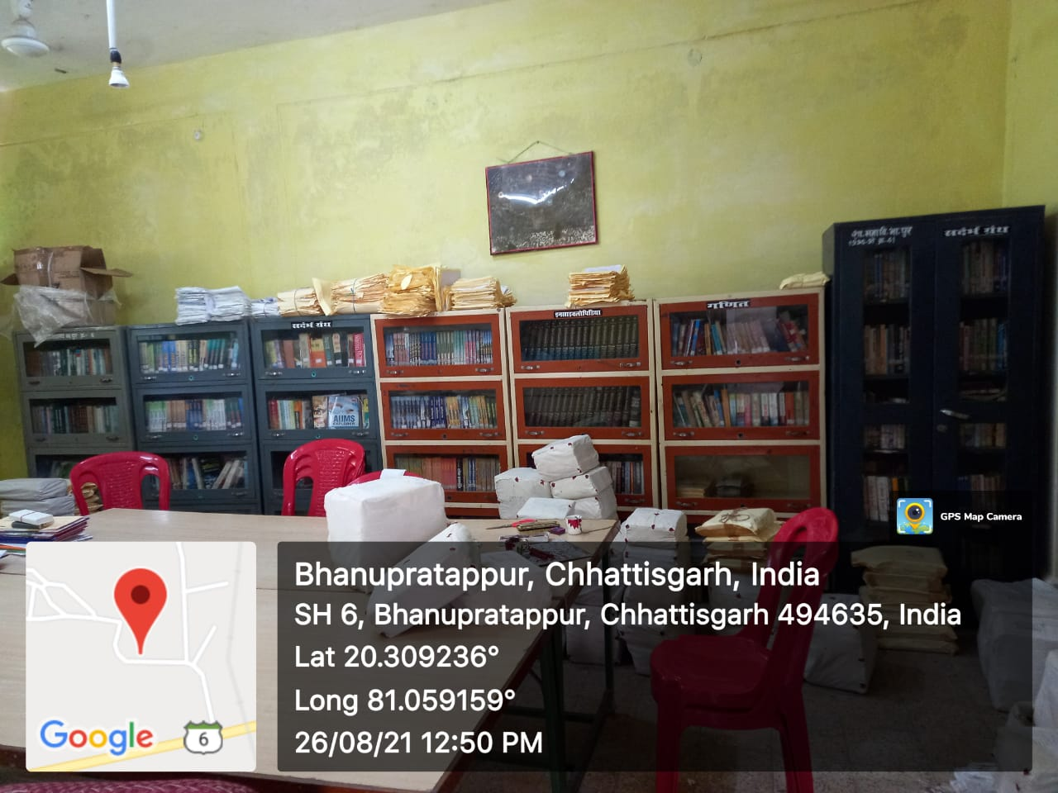
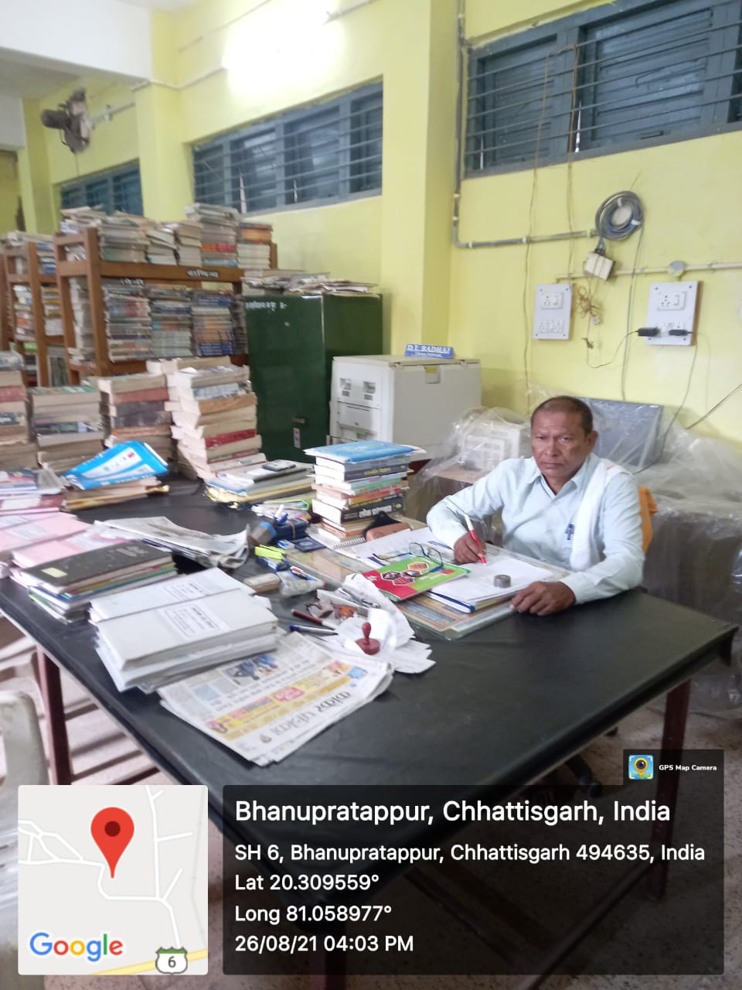
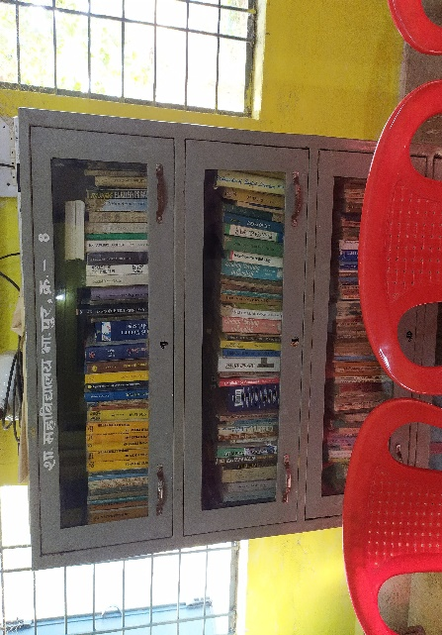
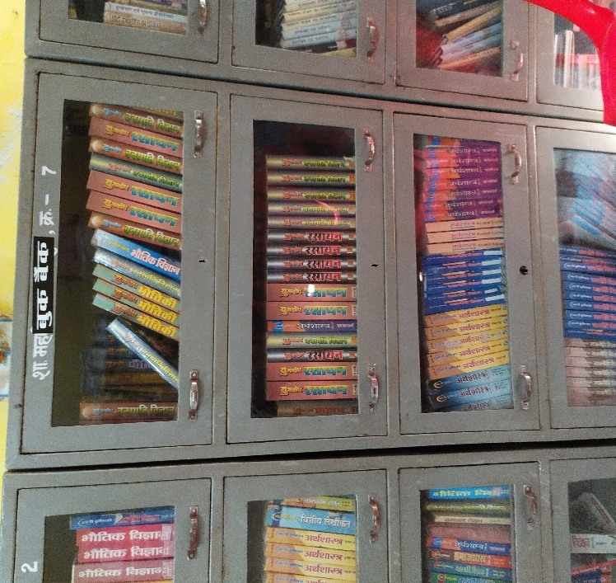
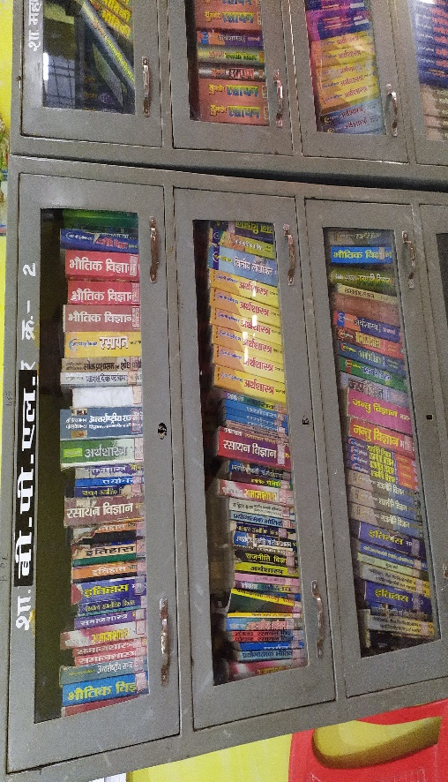
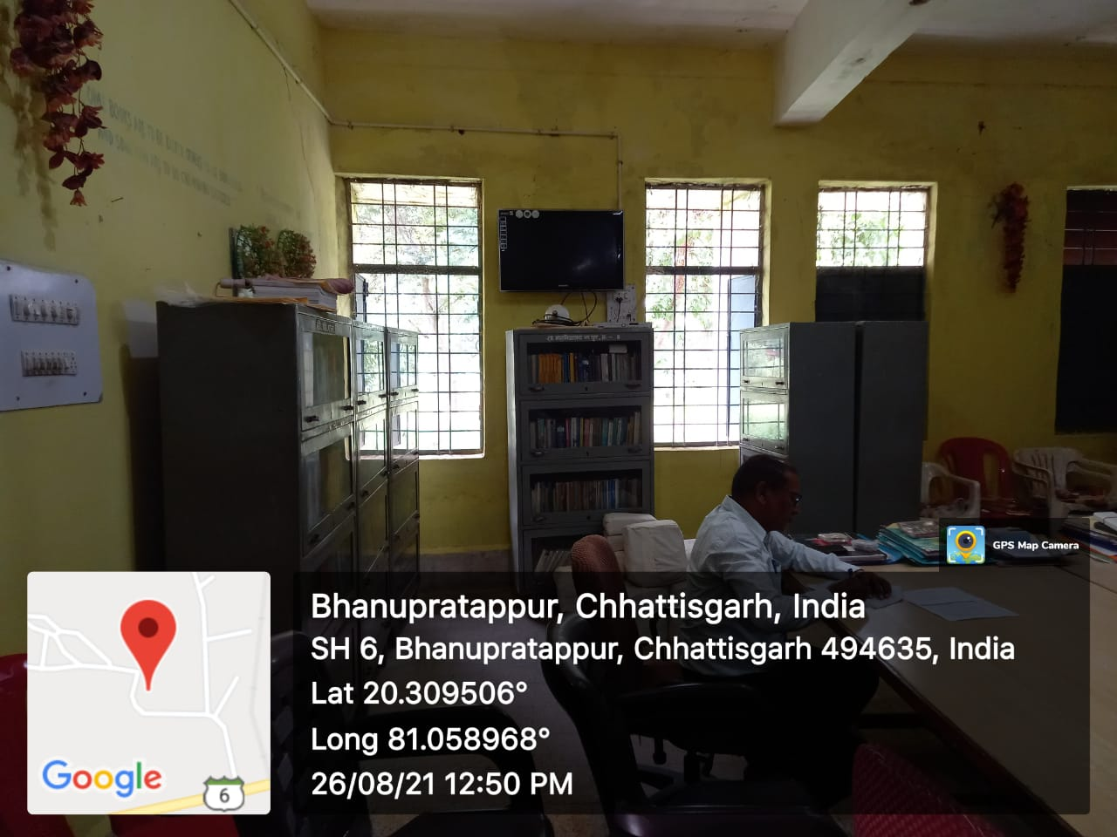
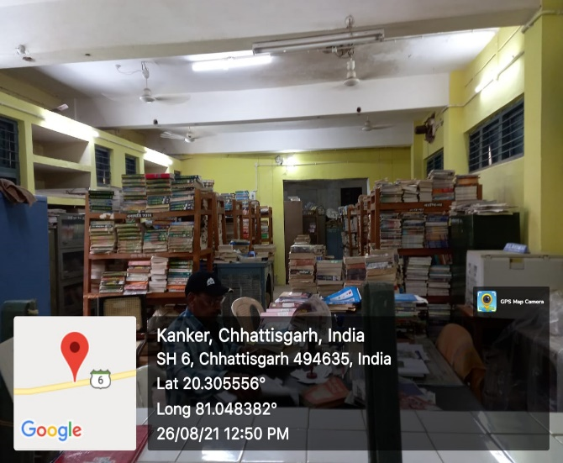
Government Maharshi Valmiki P.G. College, Bhanupratappur, Uttar Baster, Kanker, 494669

This is certifying that per day usage of library for reading room consultation and reference facilities is as follows: Detail of physical used accessing Library Year 2020-21

No of teacher & students using library per day for issue/ return books × 100
Formula=
Total no. of teacher & student
Average no. of users visiting library =120
Total no of student=1169
Total no. of teaching staff=09
Total no. of non-teaching staff=16
Total no=1194
Average=120× 100 =10.05%
1194
Average no. of users accessing library=10.05%

